  - What is Antimicrobial Resistance?
Antimicrobial drugs are substances in use to treat or prevent animal diseases, for save lives and increase productivity.
Antimicrobial Resistance (AMR) occurs when bacteria, viruses, fungi and parasites change over time and no longer respond to drugs making infections harder to treat and increasing the risk of disease spread, severe illness and death.
As a result of drug resistance antimicrobial drug become ineffective and infections become increasingly difficult or impossible to treat.
Now day’s Antimicrobial resistance (AMR) represents one of the most important human and animal health-threatening issues worldwide including our country.
Cause of Antimicrobial Resistance
Antimicrobial resistance can be caused by different ways:-
- Intrinsic (natural process)
- change to protect themselves from an antibiotic
- Extrinsic ways happens as a result of the following activities:-
-Incomplete treatment cycle
-Use of drug which is not prescribed by animal health professions.
-Misuse and overuse of antimicrobials.
-Lack of clean water and sanitation
-Inadequate diseases prevention and control
-Lack of training of professionals on major risk factors of AMR
-Lack of awareness: There is still lack of awareness among many veterinarians and farm owners on the impact of AMR to human, animal and environment health.
• Lack of information concerning the existence and prevalence of AMR in animals and animal products.
-Poor communication between animal health profession and animal owner.
• Lack of adequate ‘One Health’ integration between environment, animal, and human health care.
- Poor adherence practice of antimicrobial stewardship among practitioners
Impacts of antimicrobial resistance
The impact of AMR is national and global.
Some of the impacts are;-
-AMR is among top 10 threats for global health according to WHO
-Enhance morbidity and mortality.
-Reduce production outcomes
-increased healthcare costs
-reduce food security and increase poverty
-Increase side effect of drug
-Drug which was resisted is Out of service or use.
-Threat of animal welfare
-Enhance Environmental pollution and climate change

How we prevent antimicrobial resistance
-Animal owner must use prescribed drug by veterinarian and legal source only and follow all label or veterinary directions exactly. This includes application method and dose rate
-Increasing stakeholder awareness and engagement to foster change.
-Animal health profession must take a lead role in antimicrobial stewardship programs to change those practices that are contributing to the inappropriate use of antibiotics.
-Animal health profession involved in the treatment of livestock can only use veterinary drug under strict legislative controls and must follow the rules relating to veterinary drug regulation and directives
-Do not use unknown source of drug on livestock
-Appropriate actions should be taken by policy makers on prevention and containment of AMR.

-Protecting the environmental and self-sanitation
-optimizing the use of antibiotics in human and animal health
-Strengthening surveillance and research to support evidence based decision.
-Adherence good practice of antimicrobial stewardship

The way forward
- Training animal health professions and stakeholders.
- Developing different reading materials and distribute throughout the country.
- Unfold the impact antibiotic resistance of by media like TV and radio and newspaper.
- Make collaboration with other sectors or stake holder.
- Strengthening surveillance and data generation
- Strengthening monitoring and evaluation between stakeholders
Address: Addis Ababa, Ethiopia, Kirkos sub city woreda 06
Website www.eaa.gov.et
Email inf@eaa.gov.et
PO.BOX 31303
Phone No 251115524045
Free phone No 8083

Ethiopian Agricultural Authority
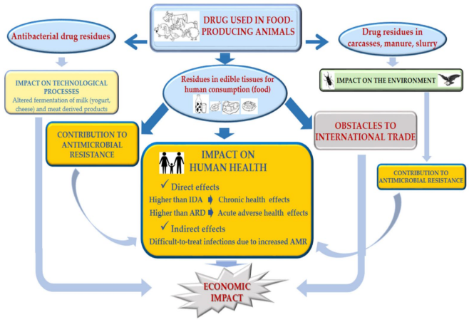
Antimicrobial Resistance (AMR) and its impacts

Preventing antimicrobial Resistance Together
Address: Addis Ababa, Ethiopia, Kirkos sub city woreda 06
Website: www.eaa.gov.et
Email: inf@eaa.gov.et
Po.box: 31303
Phone No: 251115524045
Free call No: 8083

